## Benefits

* Solvent Free
* Excellent Temperature Performance
* High Green Strength
* Low application viscosity

## Description

Non hazardous, fast curing, flexible solvent free one component PUR Reactive Hotmelt adhesive for bonding textile materials.

## Uses

Lamination of scouring pads, automotive textiles, garment textiles

Adhesive

# PUR Hotmelt Adhesive for Textile Bonding

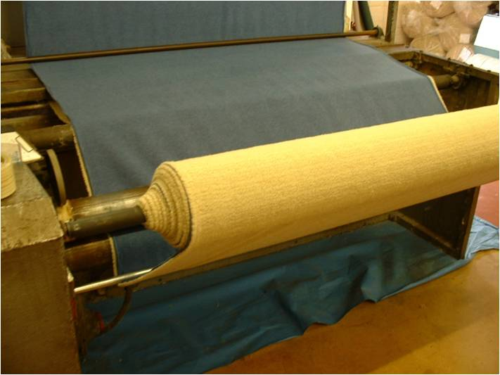

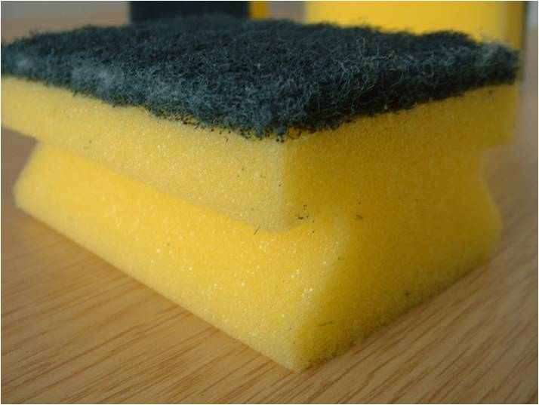

# PUR Hotmelt Adhesive for Textile Bonding

### Technical INFORMATION

The figures below are typical properties achieved in laboratory tests at 21oC and 55% Relative Humidity

Temperature Resistance  
Resistant to temperatures of up to +120oC for long periods.

Chemical Resistance   
To various acids, diesel and petrol as well as strong bases.

### Environmental Impact

The finished system is assessed as non-hazardous to health and the environment. The long service life and seamless surface reduce the need for repairs, maintenance and cleaning. Environmental and health considerations are controlled during manufacture of the products by Leeson Polyurethanes staff.

## Further Information

To ensure you are specifying a fit for purpose surface for your project please consult our Area Sales Manager for your area or visit our website.

Adhesive

### Product Specification

Product: Leeson PUR Hotmelt Adhesives  
Manufacturer: Leeson Polyurethanes Ltd.  
Telephone: + 44 (0) 1926 833367

### Substrate Requirements

Most commonly used textiles

### Products Included in this System

Wide range of products depending on the customers’ requirements, including PUR5025 and PUR4911.

Detailed installation instructions are available   
on request.

### Important Note

Leeson Polyurethanes’ products are guaranteed against defective materials and manufacture and are sold subject to its standard Terms and Conditions of Sale, copies of which can be obtained on request.